FINALS-LAB 3-INFOE 3
Stephen Gabarda

import csv
import copy

def load_raw_data(filename="anonymized_hr_data.csv"):
raw_data = []
with open(filename, mode='r', newline='', encoding='utf-8') as file:
reader = csv.DictReader(file)
for row in reader:
raw_data.append(row)
return raw_data

raw_data = load_raw_data("anonymized_hr_data.csv")

new_data = copy.deepcopy(raw_data)

hit_list = ["name", "medical_risk"]

for record in new_data:
for key in hit_list:
record.pop(key, None)

print("First cleaned record:")
print(new_data[0])

output_file = "GlobalCorp_PrivacyCleaned.csv"
if new_data:
# Get remaining fieldnames from the first cleaned record
fieldnames = list(new_data[0].keys())

with open(output_file, mode='w', newline='', encoding='utf-8') as file:
writer = csv.DictWriter(file, fieldnames=fieldnames)
writer.writeheader()
writer.writerows(new_data)

print(f"\nExported cleaned data to {output_file}")
print(f"Columns remaining: {fieldnames}")
else:
print("No data to export.")

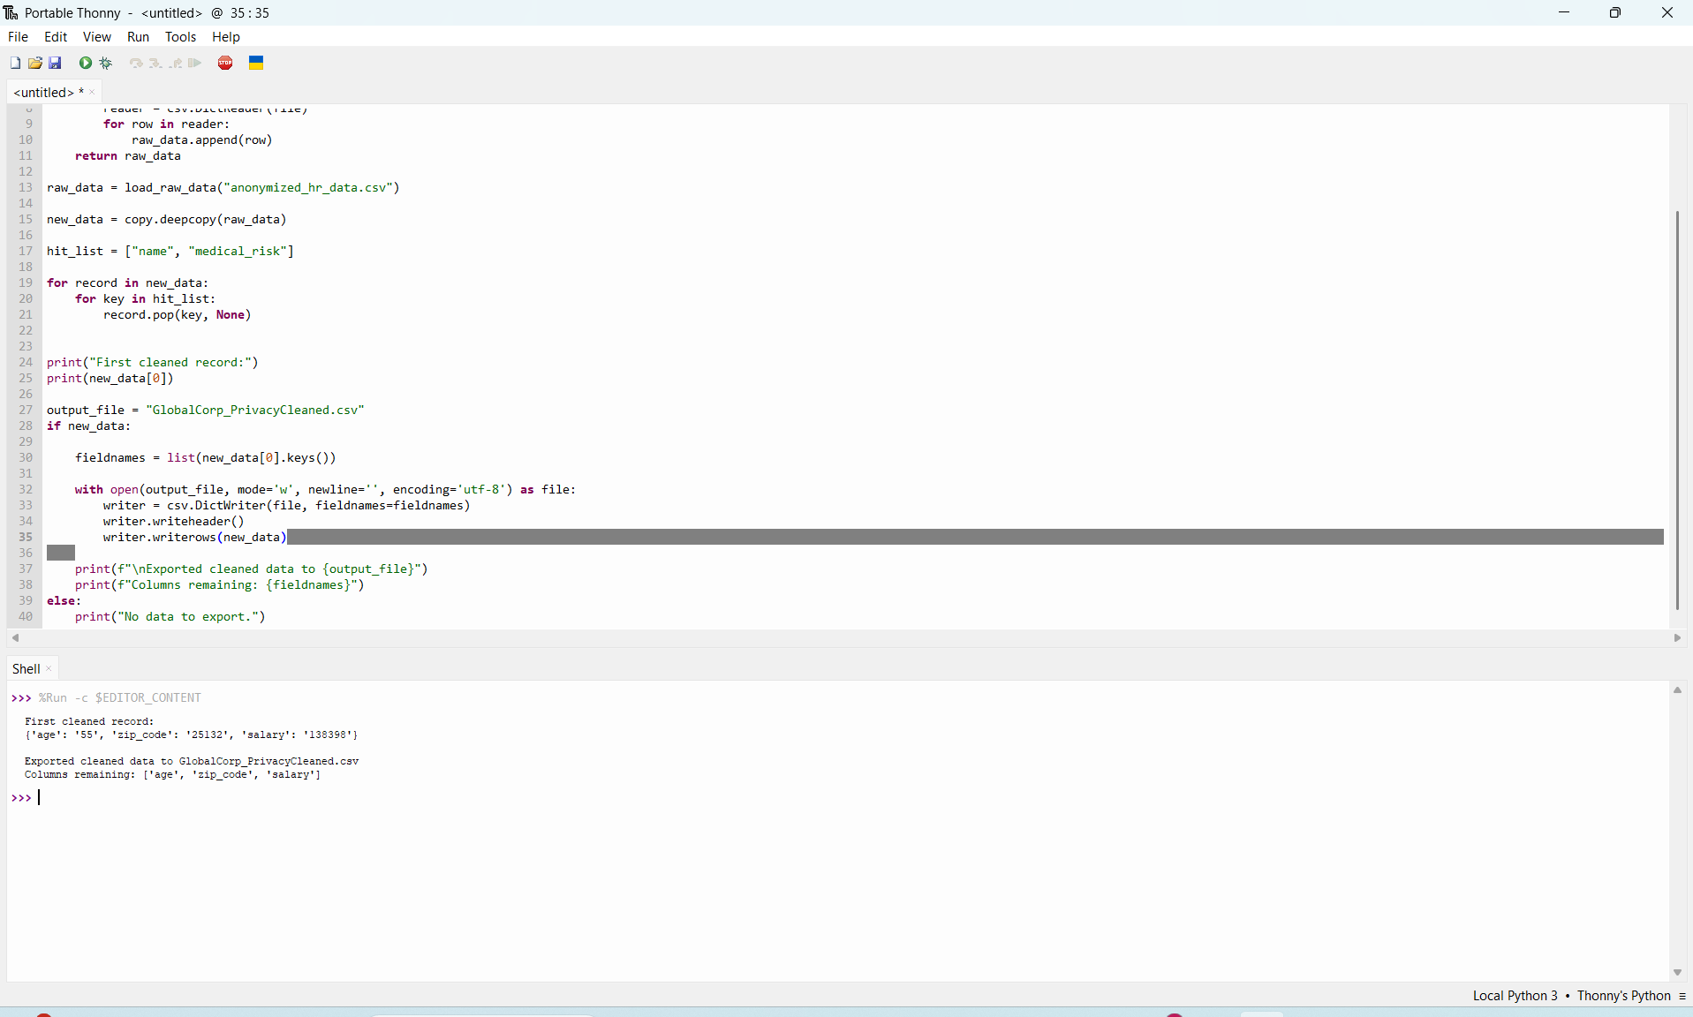

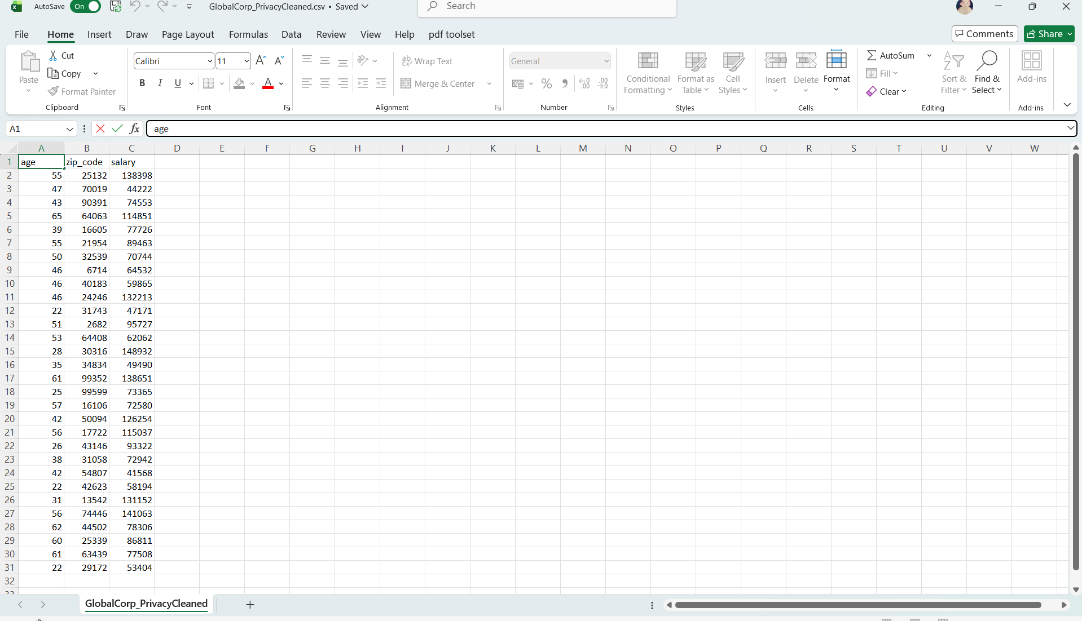

Objective
- Identify and remove "Direct Identifiers" from the GlobalCorp dataset to prevent re-identification
- Identify and remove "High-Risk Outliers" (specifically the medical_risk column flagged by the legal team) to prevent re-identification

